**DAY 1 - CA - SOFTWARE**

**System Software:**

System software is a type of software that is designed to operate and control computer hardware components, providing a platform for running application software. It acts as an intermediary between the computer hardware and user-level applications, managing the computer's resources and providing common services to applications.

**Examples of system software include:**

Operating Systems (OS): Windows, macOS, Linux, Android, iOS

Device Drivers: Printer drivers, graphics drivers, sound drivers, network drivers

Firmware: BIOS, UEFI, router firmware, embedded system firmware

Utility Software: Disk formatting tools, disk compression tools, antivirus software

Programming Languages: Compilers, interpreters, assemblers (e.g., GCC, Python, Java)

System Libraries: Dynamic link libraries (DLLs), shared libraries (e.g., libc, libm)

**System software provides various functions, such as:**

Process management

Memory management

File system management

Input/Output (I/O) management

Security and access control

Networking and communication

**Application Software:**

Application software, also known as productivity software, is designed to perform specific tasks or solve particular problems. It runs on top of system software and uses the services provided by the system software to interact with the computer hardware.

**Examples of application software include:**

Productivity Software: Microsoft Office, Google Docs, LibreOffice

Graphics and Design Software: Adobe Photoshop, Illustrator, Sketch

Games: Video games, mobile games, online games

Internet Browsers: Google Chrome, Mozilla Firefox, Safari

Media Players: VLC media player, Windows Media Player, iTunes

Database Management Systems: MySQL, PostgreSQL, Microsoft SQL Server

Accounting and Financial Software: QuickBooks, Xero, SAP

**Application software provides various functions, such as:**

Word processing and document creation

Image and video editing

Data analysis and visualization

Communication and collaboration

Entertainment and leisure

Financial management and accounting

**DAY 2 - CA - SOFTWARE**

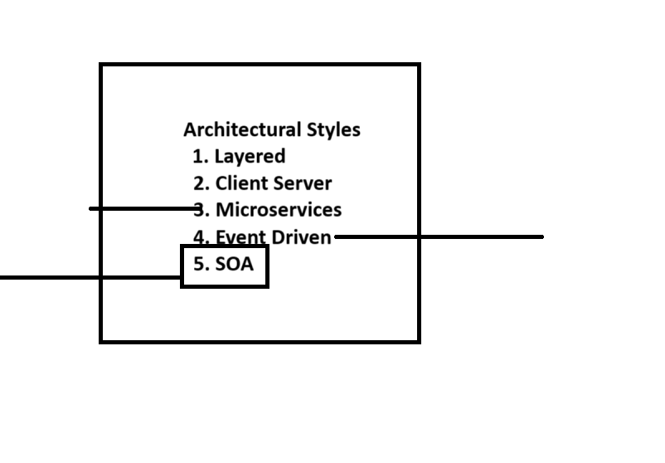

**Architectural styles**

* Layered
* Client server
* Micro Services
* Event Drivers
* Service Oriented Architecture (SOA)

**Case Study: Car Rental System**

#### 1. Introduction

The Car Rental System (CRS) is a software application designed to facilitate the rental of vehicles to customers. It allows customers to search for available cars, make reservations, and manage their rental details. The system also provides an interface for administrators to manage the fleet of cars, reservations, and customer details.

#### 2. System Requirements

**Functional Requirements:**

* User Registration and Login
* Car Search and Availability Check
* Booking and Reservation
* Payment Processing
* Customer Profile Management
* Administrator Dashboard
* Fleet Management
* Reporting and Analytics

**Non-functional Requirements:**

* Performance: The system should handle a large number of concurrent users.
* Security: The system should ensure data security and user privacy.
* Usability: The system should have an intuitive and user-friendly interface.
* Scalability: The system should be scalable to accommodate future growth.

#### 3. Use Case Diagram & UML Diagram

We have four main Actors in our system:

* **Receptionist:** Mainly responsible for adding and modifying vehicles and workers. Receptionists can also reserve vehicles.
* **Member:** All members can search the catalog, as well as reserve, pick-up, and return a vehicle.
* **System:** Mainly responsible for sending notifications about overdue vehicles, canceled reservation, etc.
* **Worker:** Mainly responsible for taking care of a returned vehicle and updating the vehicle log.

Here are the top use cases of the Car Rental System:

* **Add/Remove/Edit vehicle:** To add, remove or modify a vehicle.
* **Search catalog:** To search for vehicles by type and availability.
* **Register new account/Cancel membership:** To add a new member or cancel an existing membership.
* **Reserve vehicle:** To reserve a vehicle.
* **Check-out vehicle:** To rent a vehicle.
* **Return a vehicle:** To return a vehicle which was checked-out to a member.
* **Add equipment:** To add an equipment to a reservation like navigation, child seat, etc.
* **Update car log:** To add or update a car log entry, such as refueling, cleaning, damage, etc.

**UML diagram points:**

**Actors:**

* Customer
* Employee
* Manager (optional)
* Insurance Company (implicit)

**Customer Use Cases:**

* Register for an account
* Login to the system
* Search for cars (by type, features, etc.)
* View car details (including price, availability)
* Select a car for rental
* Make a reservation (specify dates, pick-up/drop-off locations)
* Maintain car rental information (view reservations, modify pick-up/drop-off)

**Employee Use Cases:**

* View daily and monthly rental reports

**Manager Use Cases (optional):**

* Generate bills for completed rentals

**Additional Points:**

* The diagram might show interaction with the insurance company (e.g., customer provides insurance information).
* The system likely manages car availability based on reservations.
* Extensions can include loyalty programs, online payments, or damage reporting.

Here is the use UML diagram of our Car Rental System:

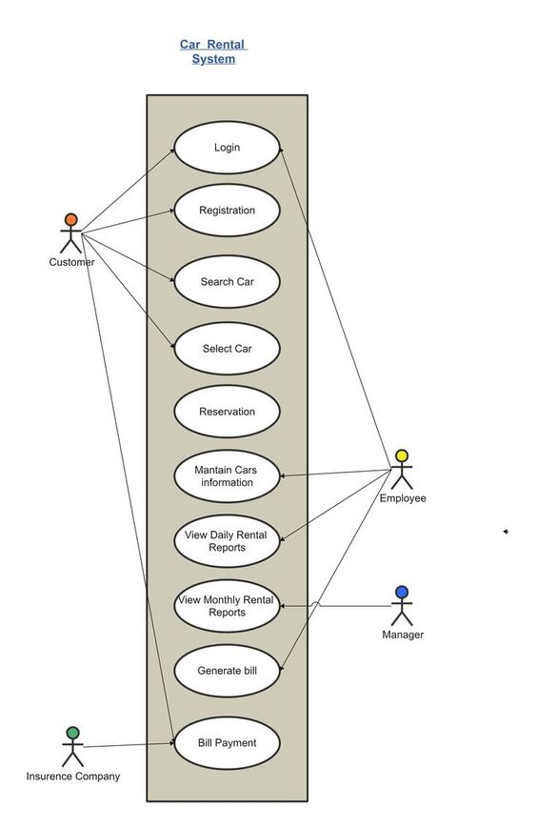

Here is the use case diagram of our Car Rental System:

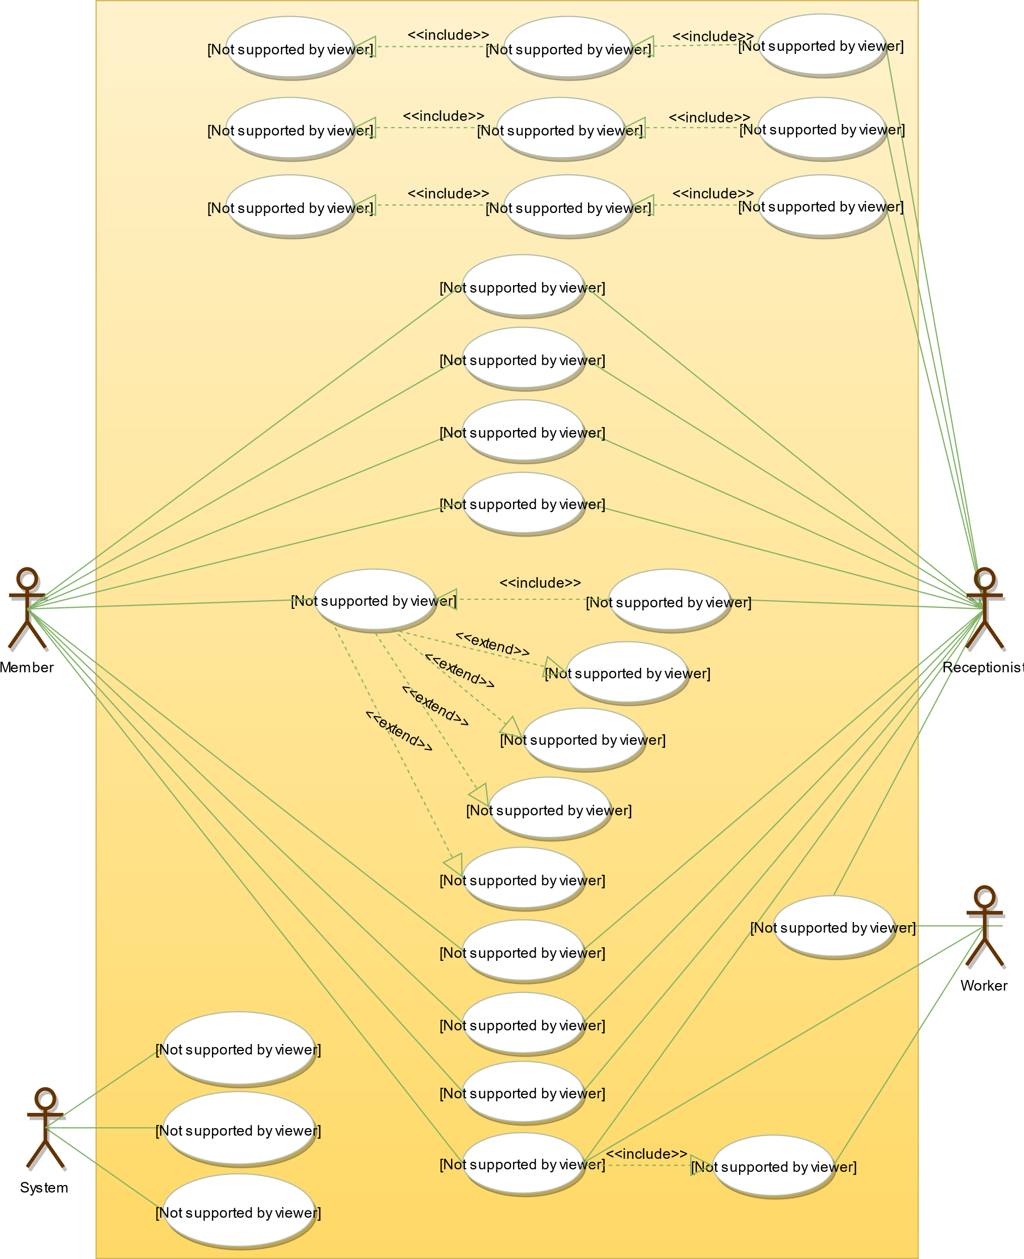

#### 4. System Design

The system design involves several components interacting with each other. The primary components include:

**1. User Interface (UI):**

* Web Application
* Mobile Application

**2. Business Logic Layer:**

* User Management Service
* Car Management Service
* Reservation Service
* Payment Service
* Reporting Service

**3. Data Access Layer:**

* User Database
* Car Database
* Reservation Database
* Payment Database

**4. External Services:**

* Payment Gateway

#### Component Diagram

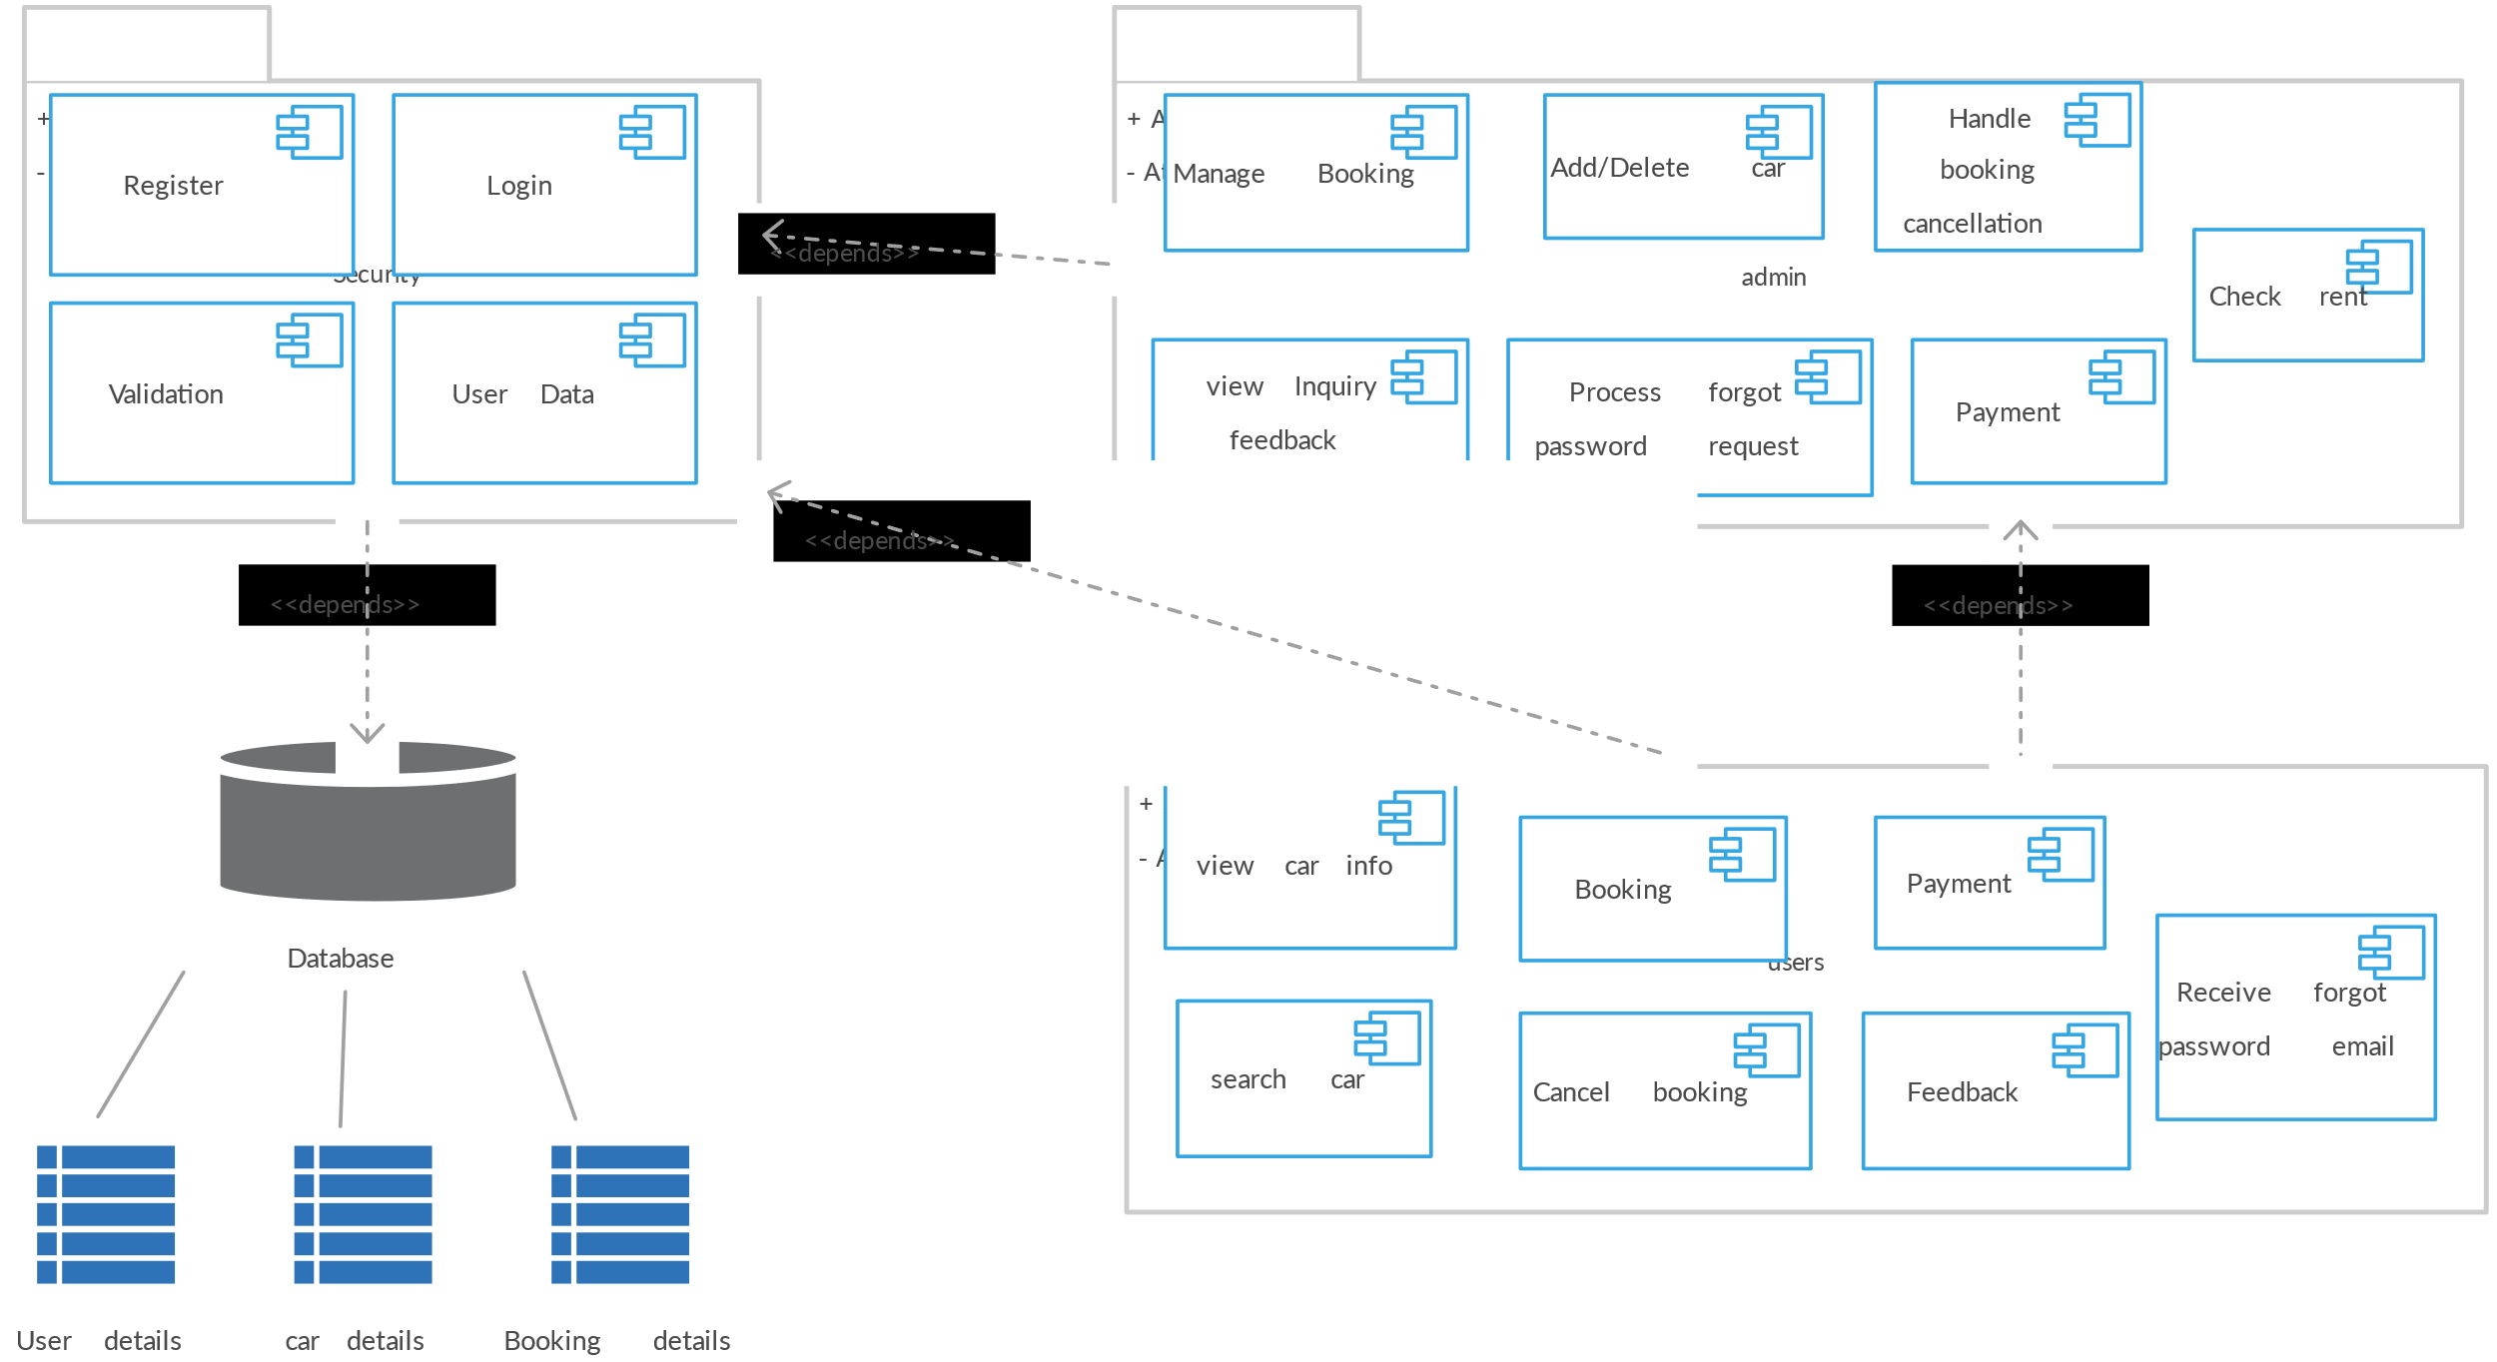

1. **Sequence Diagram**

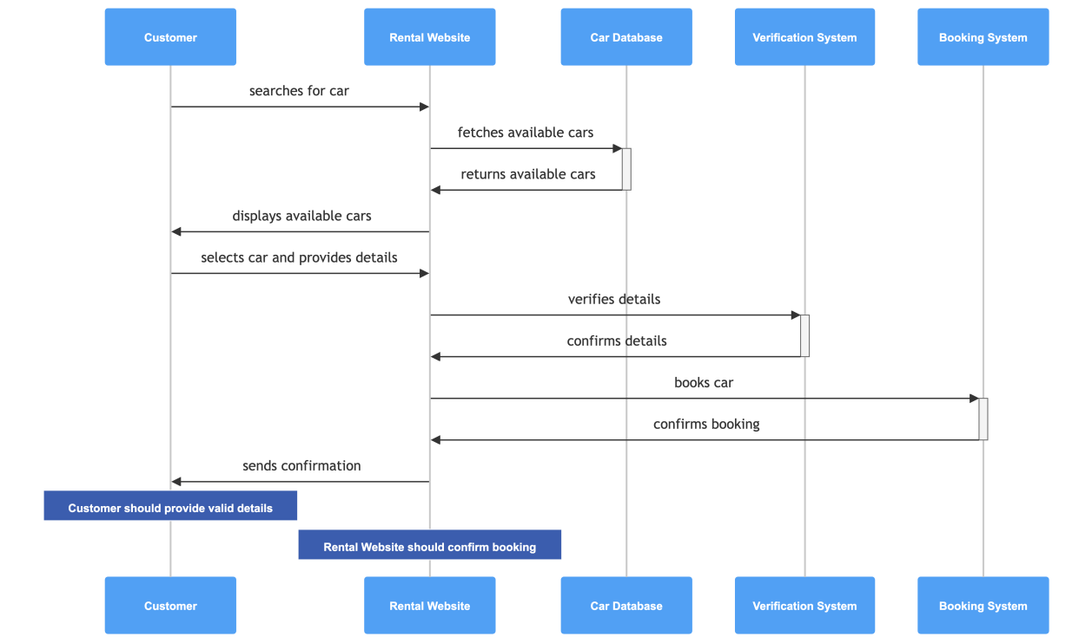

#### 7. Database Design

**User Table:**

* UserID (Primary Key)
* UserName
* Password
* Email
* Phone
* Address

**Car Table:**

* CarID (Primary Key)
* Make
* Model
* Year
* Status (Available, Rented, Maintenance)

**Reservation Table:**

* ReservationID (Primary Key)
* UserID (Foreign Key)
* CarID (Foreign Key)
* ReservationDate
* StartDate
* EndDate
* Status (Reserved, Completed, Cancelled)

**Payment Table:**

* PaymentID (Primary Key)
* ReservationID (Foreign Key)
* Amount
* PaymentDate
* PaymentStatus

#### 8. Implementation

The Car Rental System can be implemented using various technologies. A typical tech stack might include:

* **Frontend:** React.js for web application, React Native for mobile application
* **Backend:** Node.js with Express.js
* **Database:** MongoDB
* **Payment Gateway:** Stripe or PayPal
* **Hosting:** AWS or Heroku

#### 9. Testing

**Test Cases:**

* User Registration and Login
* Car Search Functionality
* Reservation Creation and Management
* Payment Processing
* Administrator Functions
* Performance Testing
* Security Testing

#### 10. Conclusion

The Car Rental System provides a comprehensive solution for managing car rentals, from user registration to car reservation and payment processing. By adopting a microservices architecture, the system ensures scalability, maintainability, and ease of integration with external services.

This case study provides a high-level overview of the system. In practice, detailed documentation, coding standards, and best practices should be followed to ensure the successful implementation and deployment of the system.

**DAY 3 - CA – SOFTWARE**

* **Car Rental System PPT.**

**DAY 4 - CA – SOFTWARE**

**1.MVC (Model-View-Controller) and its variants?**

MVC (Model-View-Controller) is a design pattern that separates an application into three interconnected components: the Model, the View, and the Controller. This separation helps in organizing code and promotes scalability and maintainability.

**Core MVC Components:**

1. Model:
   * Represents the data and the business logic of the application.
   * Directly manages the data, logic, and rules of the application.
   * Notifies the View of any data changes so the display can be updated.
2. View:
   * Represents the UI (user interface) of the application.
   * Displays the data from the Model to the user.
   * Sends user commands to the Controller.
3. Controller:
   * Acts as an intermediary between Model and View.
   * Receives input from the View, processes it (often involving the Model), and updates the View accordingly.

**Variants of MVC:**

While MVC is a foundational pattern, several variants and extensions have been developed to address specific needs and use cases. Here are some notable ones:

1. MVP (Model-View-Presenter):
   * Model: Same as in MVC.
   * View: Displays data and sends user interactions to the Presenter.
   * Presenter: Retrieves data from the Model and formats it for display in the View. Unlike the Controller in MVC, the Presenter handles more of the presentation logic and communicates directly with the View.
2. MVVM (Model-View-ViewModel):
   * Model: Same as in MVC.
   * View: Same as in MVC.
   * ViewModel: An abstraction of the View that manages the state and behavior of the view independently of the UI. It exposes properties and commands that the View can data-bind to, facilitating a clear separation between the View and Model.
3. MVA (Model-View-Adapter):
   * Model: Same as in MVC.
   * View: Same as in MVC.
   * Adapter: Acts as an intermediary, adapting the interface of the Model to be suitable for the View. This pattern is often used in situations where the View requires data in a format that the Model does not provide directly.
4. HMVC (Hierarchical Model-View-Controller):
   * A modular extension of MVC where each module can have its own MVC triad. This allows for more organized and scalable applications, especially in large projects.
5. PAC (Presentation-Abstraction-Control):
   * Presentation: Manages the presentation and user interface.
   * Abstraction: Encapsulates the core data and business logic.
   * Control: Connects Presentation and Abstraction, controlling the flow of data and operations.

**2.Software Design Patterns:**

Software design patterns in computer architecture (CA) involve recurring solutions to common problems or tasks in the design and organization of computing systems, both in hardware and software. These patterns help architects and designers create scalable, efficient, and maintainable systems. Here's an overview of some key patterns and their relevance to computer architecture.

1. **Layered Architecture Pattern**:
   * **Definition**: Organizes the system into hierarchical layers, each layer providing services to the layer above and receiving services from the layer below.
   * **Example**: Operating system structure with application, service, kernel, and hardware layers.
2. **Client-Server Pattern**:
   * **Definition**: Divides the system into client components that request services and server components that provide services.
   * **Example**: Web applications where a web browser acts as the client and a web server provides the requested resources.
3. **Microkernel Pattern**:
   * **Definition**: Minimizes the core functions of the system kernel, with additional services running in user space.
   * **Example**: Operating systems like MINIX and QNX.
4. **Pipes and Filters Pattern**:
   * **Definition**: Decomposes a task into a series of processing steps (filters) connected by data streams (pipes).
   * **Example**: Unix command pipelines like cat file.txt | grep "pattern" | sort | uniq.
5. **Event-Driven Architecture Pattern**:
   * **Definition**: System flow is determined by events, which trigger responses from event handlers.
   * **Example**: User interfaces where user actions trigger event handlers.
6. **Shared-Nothing Architecture**:
   * **Definition**: Each component is independent, not sharing resources with others, facilitating parallel processing.
   * **Example**: Distributed databases and web servers.
7. **Cache Pattern**:
   * **Definition**: Stores frequently accessed data closer to the processing unit to reduce access time.
   * **Example**: CPU caches.
8. **Map-Reduce Pattern**:
   * **Definition**: Divides a task into smaller subtasks processed in parallel, then combines the results.
   * **Example**: Big data processing frameworks like Hadoop.Top of Form

**3.what is Cloud Computing and Services and Basics of cloud computing. SaaS, PaaS, IaaS.**

Cloud computing is a model for delivering computing services over the internet. These services include storage, processing power, and applications, which can be rapidly provisioned and released with minimal management effort.

**Basics of Cloud Computing:**

1. On-Demand Self-Service: Users can provision computing resources as needed without human intervention.
2. Broad Network Access: Services are available over the network and accessed through standard mechanisms.
3. Resource Pooling: Provider’s computing resources are pooled to serve multiple users, with different physical and virtual resources dynamically assigned and reassigned according to demand.
4. Rapid Elasticity: Resources can be rapidly and elastically provisioned to scale out and released to scale in, appearing to be unlimited to the consumer.
5. Measured Service: Cloud systems automatically control and optimize resource use by leveraging a metering capability, providing transparency for both the provider and consumer of the utilized service.

**Cloud Service Models:**

1. Software as a Service (SaaS):
   * Description: Delivers software applications over the internet, on a subscription basis.
   * Example: Google Workspace (formerly G Suite), Microsoft Office 365.
   * Usage: Users access applications via web browsers without managing the underlying infrastructure.
2. Platform as a Service (PaaS):
   * Description: Provides a platform allowing customers to develop, run, and manage applications without dealing with the underlying infrastructure.
   * Example: Google App Engine, Microsoft Azure App Services.
   * Usage: Developers use it to build applications without worrying about server management, storage, and networking.
3. Infrastructure as a Service (IaaS):
   * Description: Offers fundamental computing resources like virtual machines, storage, and networks.
   * Example: Amazon Web Services (AWS), Microsoft Azure, Google Cloud Platform (GCP).
   * Usage: Users can rent virtualized hardware and networking, managing operating systems, applications, and middleware.

Bottom of Form

**4.What is Docker**

Docker is an open-source platform designed to automate the deployment, scaling, and management of applications using containerization. Containers are lightweight, portable, and self-sufficient units that include everything needed to run a piece of software, including the code, runtime, system tools, libraries, and settings.

**Key Concepts of Docker:**

1. Containers:
   * Definition: Lightweight, standalone, and executable software packages that contain everything needed to run an application.
   * Features: Encapsulate the application and its dependencies, ensuring consistency across different environments.
2. Images:
   * Definition: Read-only templates used to create Docker containers.
   * Features: Built from a series of layers, each representing a set of file changes or additions.
3. Docker file:
   * Definition: A script containing a set of instructions to build a Docker image.
   * Features: Includes commands to install software, copy files, and configure the container environment.
4. Docker Hub:
   * Definition: A public repository where users can find and share Docker images.
   * Features: Provides access to a vast library of pre-built images.
5. Docker Compose:
   * Definition: A tool for defining and running multi-container Docker applications.
   * Features: Uses a YAML file to configure the application's services, networks, and volumes.
6. Docker Swarm:
   * Definition: A native clustering and orchestration tool for Docker.
   * Features: Enables the management of a cluster of Docker engines, providing high availability and scalability.

**Benefits of Docker:**

1. **Portability**: Containers can run consistently across different environments, from development to production.
2. **Isolation**: Containers encapsulate the application and its dependencies, preventing conflicts with other applications.
3. **Efficiency**: Containers share the host system’s kernel and resources, leading to lower overhead compared to virtual machines.
4. **Scalability**: Docker makes it easy to scale applications horizontally by running multiple container instances.
5. **Rapid** **Deployment**: Containers can be quickly started or stopped, facilitating continuous integration and continuous deployment (CI/CD) practices.

**5.What is Containerization**

Containerization is a lightweight form of virtualization that involves encapsulating an application and its dependencies into a container. This container includes everything needed to run the application, such as the code, runtime, system tools, libraries, and settings, ensuring consistency across different environments.

**Key Concepts of Containerization:**

1. Containers:
   * Definition: Portable, self-sufficient units that package the application and its dependencies.
   * Features: Isolated from the host system and other containers, ensuring no conflicts.
2. Images:
   * Definition: Read-only templates used to create containers.
   * Features: Built from a series of layers, each representing a set of file changes or additions.
3. Container Engine:
   * Definition: Software that creates, manages, and runs containers.
   * Examples: Docker, Podman, Containerd.
4. Container Orchestration:
   * Definition: Management of multiple containers to ensure they run efficiently and reliably.
   * Examples: Kubernetes, Docker Swarm, Apache Mesos.

**Benefits of Containerization:**

1. **Portability**: Containers can run on any system that supports the container runtime, from development laptops to production servers, ensuring consistent behavior.
2. **Efficiency**: Containers share the host system’s operating system kernel, making them more lightweight and efficient compared to traditional virtual machines.
3. **Isolation**: Containers run in isolated environments, preventing conflicts between applications and improving security.
4. **Scalability**: Containers can be easily scaled up or down, allowing for responsive scaling of applications to handle varying loads.
5. **Fast** **Deployment**: Containers can be started, stopped, and replicated quickly, facilitating rapid development cycles and continuous deployment.

**6.What is Image Management**

**Image management** in the context of computer architecture, particularly in containerization, refers to the processes and tools involved in creating, storing, distributing, and maintaining container images. Container images are immutable files that package an application and its dependencies, allowing for consistent and reproducible environments.

**Key Concepts of Image Management**

1. **Image Creation**:
   * **Definition**: The process of defining and building container images.
   * **Tools**: Docker, Podman.
   * **Example**: Writing a Dockerfile to specify the application's environment and dependencies.
2. **Image Storage**:
   * **Definition**: Storing built images in a central repository for easy access and distribution.
   * **Tools**: Docker Hub, Google Container Registry (GCR), Amazon Elastic Container Registry (ECR).
   * **Example**: Pushing a built image to Docker Hub for storage and sharing.
3. **Image Distribution**:
   * **Definition**: Distributing container images to various environments, such as development, testing, and production.
   * **Tools**: Container registries, CI/CD pipelines.
   * **Example**: Using a CI/CD pipeline to pull an image from a registry and deploy it to a production environment.
4. **Image Versioning**:
   * **Definition**: Managing different versions of container images to ensure compatibility and rollback capabilities.
   * **Tools**: Tags, version control within container registries.
   * **Example**: Tagging images with version numbers (e.g., v1.0, v2.0) to keep track of changes and updates.
5. **Image Security**:
   * **Definition**: Ensuring container images are free from vulnerabilities and comply with security standards.
   * **Tools**: Vulnerability scanners, security policies.
   * **Example**: Scanning images with tools like Clair or Aqua Security to detect and mitigate vulnerabilities.
6. **Image Optimization**:
   * **Definition**: Reducing the size of container images to improve efficiency and performance.
   * **Techniques**: Multi-stage builds, minimizing layers, removing unnecessary files.
   * **Example**: Using a multi-stage Dockerfile to keep the final image lightweight.

**7.What is Docker Hub and Registries**

**Docker Hub** is a cloud-based repository where Docker users and partners create, test, store, and distribute container images. It is the default public registry for Docker and provides a centralized platform for managing and sharing container images.

**Key Features:**

* **Image Repository**: Store and organize Docker images in public or private repositories.
* **Automated Builds**: Automatically build images from source code repositories.
* **Webhooks**: Trigger actions after successful image pushes or builds.
* **Collaborative Features**: Manage access controls and collaborate with team members.
* **Official Images**: Access to a wide range of curated images from Docker and verified publishers.

**Container Registries**

**Container registries** are services that store and distribute container images. They can be public or private and provide functionalities similar to Docker Hub but may offer additional features tailored for enterprise use or integration with other cloud services.

**Key Types:**

1. **Public Registries**:
   * Examples: Docker Hub, Google Container Registry (GCR), Amazon Elastic Container Registry (ECR).
   * Features: Publicly accessible, wide community access, official images.
2. **Private Registries**:
   * Examples: Self-hosted Docker Registry, Azure Container Registry (ACR), JFrog Artifactory.
   * Features: Secure, controlled access, integrated with enterprise authentication systems, custom storage options.

**Key Features:**

* **Image Storage**: Store images in a structured manner with versioning support.
* **Access Control**: Manage permissions and access to images for different users and teams.
* **Integration**: Integrate with CI/CD pipelines for automated image building and deployment.
* **Security Scanning**: Scan images for vulnerabilities and enforce security policies.
* **Replication**: Distribute images across multiple geographic locations for redundancy and performance.

8.What is Kubernetes

**Kubernetes**, often abbreviated as **K8s**, is an open-source container orchestration platform designed to automate the deployment, scaling, and management of containerized applications. It was originally developed by Google and is now maintained by the Cloud Native Computing Foundation (CNCF). Kubernetes provides a framework for automating the deployment, scaling, and management of distributed applications, across clusters of hosts.

**Key Concepts of Kubernetes**

1. **Container Orchestration**:
   * **Definition**: Automates the deployment, scaling, and management of containerized applications.
   * **Features**: Manages containerized applications across clusters of nodes, ensuring efficient resource utilization and high availability.
2. **Pods**:
   * **Definition**: The smallest deployable unit in Kubernetes, consisting of one or more containers.
   * **Features**: Pods share network and storage, allowing containers within the same pod to communicate with each other using localhost.
3. **Nodes**:
   * **Definition**: Physical or virtual machines that run Kubernetes and host multiple pods.
   * **Features**: Nodes are managed by the Kubernetes control plane and execute the containers within pods.
4. **Cluster**:
   * **Definition**: A set of nodes that run containerized applications managed by Kubernetes.
   * **Features**: Consists of a master node (control plane) that manages the cluster and worker nodes that host the pods.
5. **Control Plane**:
   * **Definition**: Manages the Kubernetes cluster and its components, including the API server, scheduler, and controller manager.
   * **Features**: Maintains cluster state, schedules applications, and manages container orchestration policies.
6. **Services**:
   * **Definition**: An abstraction that defines a logical set of pods and a policy by which to access them.
   * **Features**: Services enable decoupling between pods and external clients, providing stable endpoints for accessing applications.
7. **Deployment**:
   * **Definition**: A Kubernetes resource that manages a replicated application, ensuring the desired number of pod replicas are running at any given time.
   * **Features**: Facilitates rolling updates and rollbacks of application versions, ensuring continuous availability.

**Benefits of Kubernetes**

* **Scalability**: Kubernetes allows applications to scale horizontally by adding or removing pods based on demand.
* **Fault Tolerance**: Kubernetes automatically reschedules pods on failed nodes and replaces unhealthy containers.
* **Portability**: Kubernetes abstracts underlying infrastructure, making applications portable across different environments.
* **Automation**: Kubernetes automates repetitive tasks such as deployment, scaling, and management, improving operational efficiency.